Question 1- https://www.hackerrank.com/challenges/functions-in-c/problem
Solution
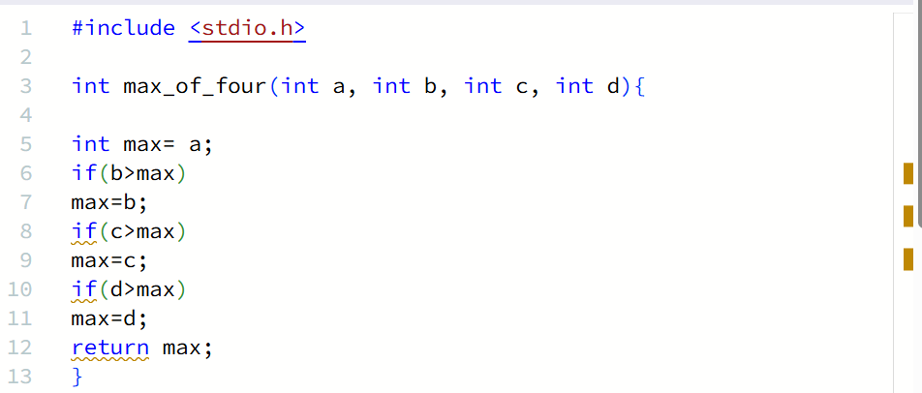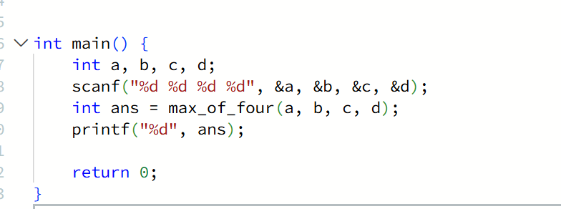

Question 2 https://leetcode.com/problems/move-zeroes/submissions/2190553349/
Solution
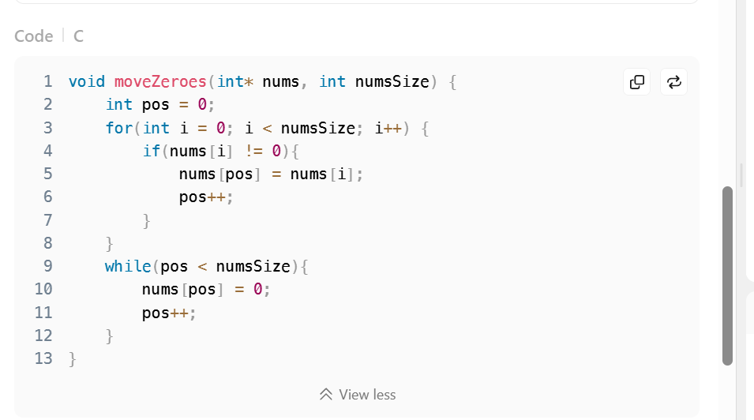
Question 3 https://www.hackerearth.com/practice/basic-programming/input-output/basics-of-input-output/practice-problems/algorithm/io-exercise/?update=google&purpose=login&source=login
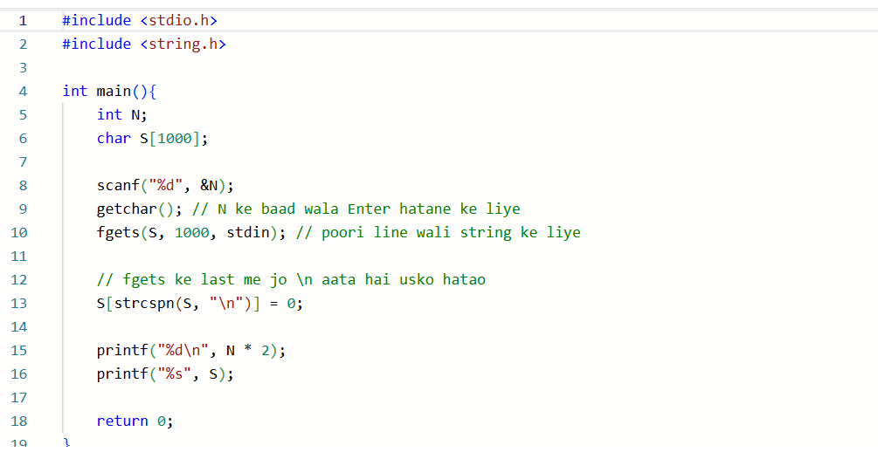
Question 4 https://www.hackerrank.com/challenges/solve-me-first/problem
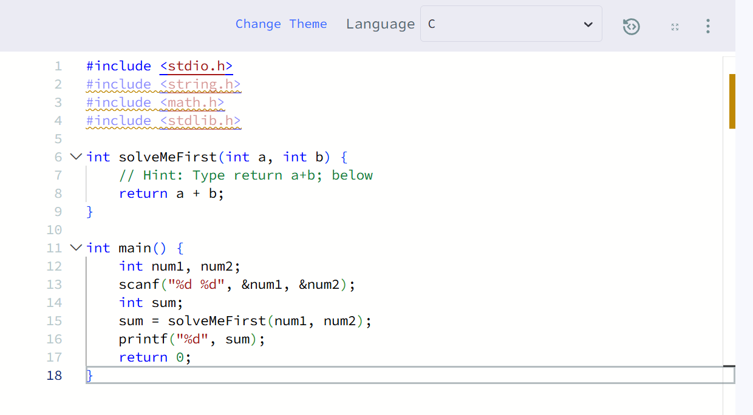
Question 5 https://www.hackerearth.com/practice/basic-programming/input-output/basics-of-input-output/practice-problems/algorithm/roy-and-profile-picture/
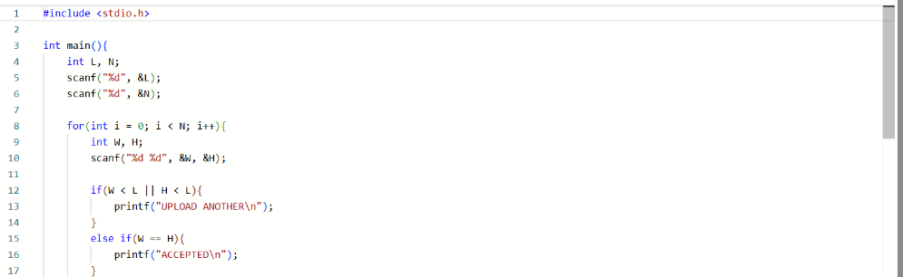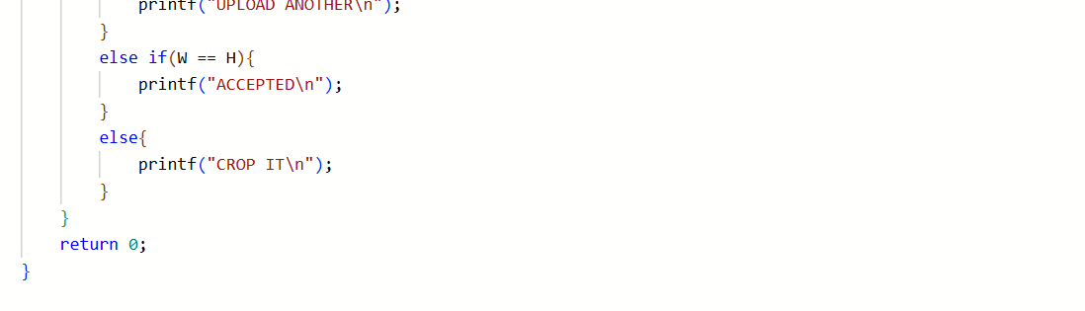

Question 6 https://www.hackerrank.com/challenges/fizzbuzz/problem
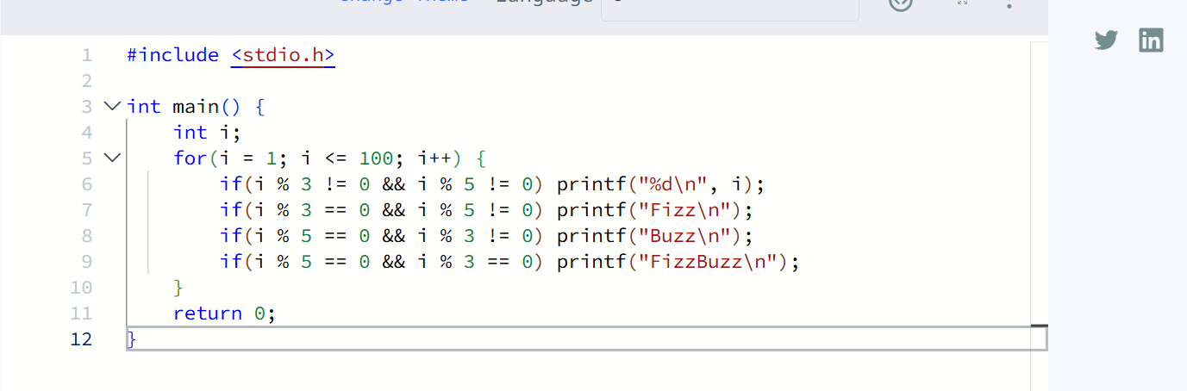

Question 7 https://www.hackerearth.com/problem/algorithm/digit-sum-4/
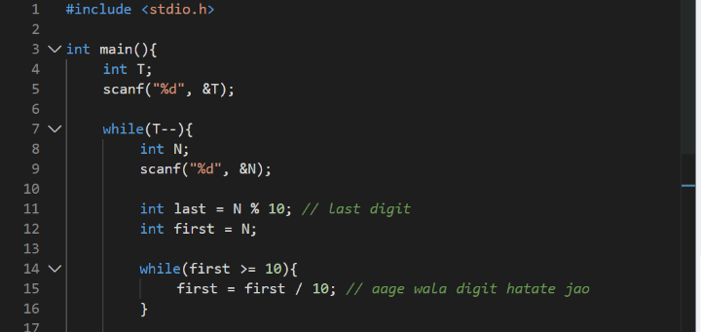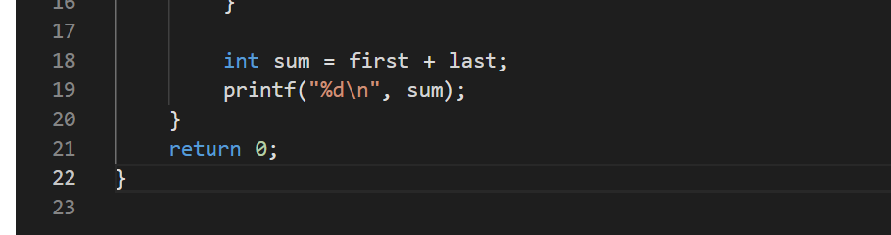

Question 8 https://leetcode.com/problems/add-two-integers/
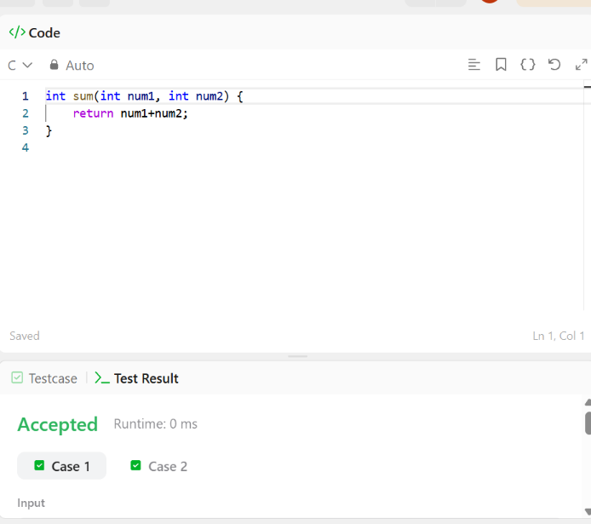

Question 9 https://leetcode.com/problems/calculate-delayed-arrival-time/submissions/2191076235/
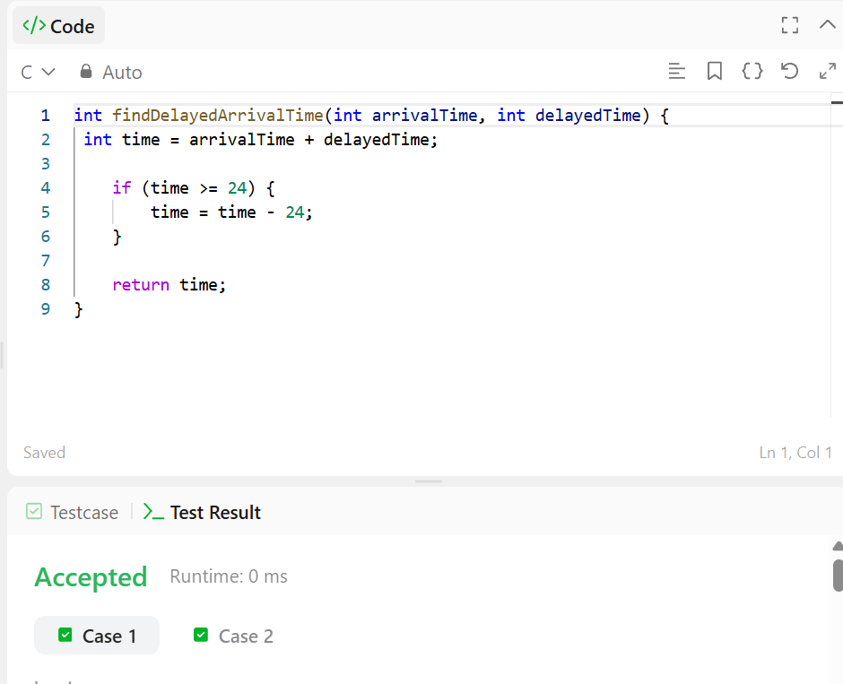

Question 10 https://leetcode.com/problems/total-distance-traveled/
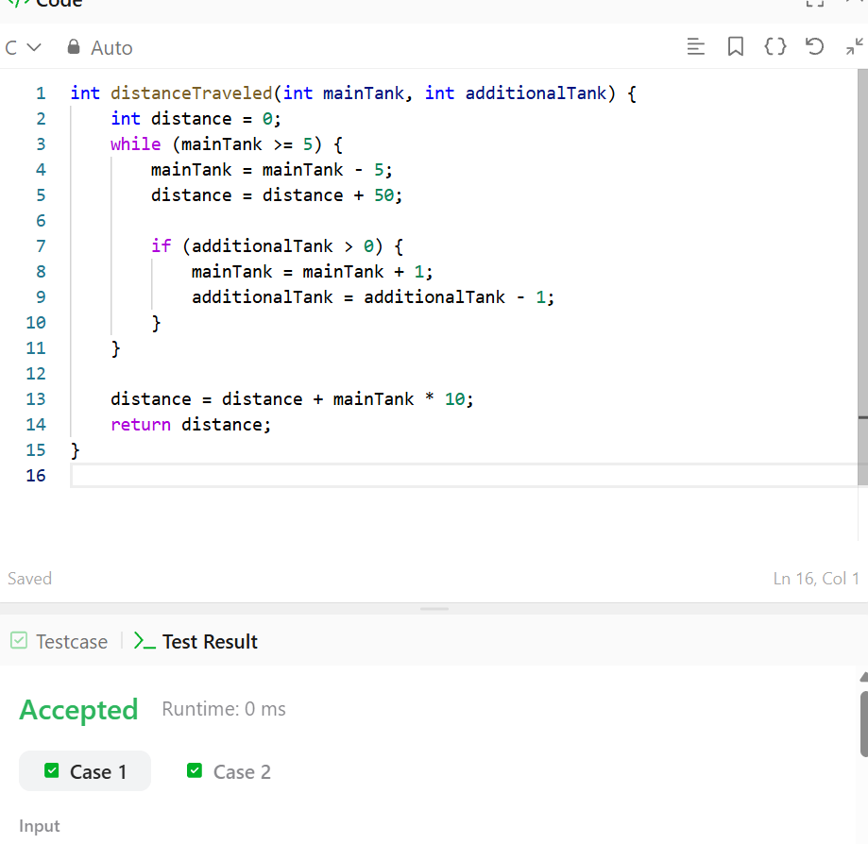

Question 11 https://leetcode.com/problems/smallest-even-multiple/submissions/2191077494/
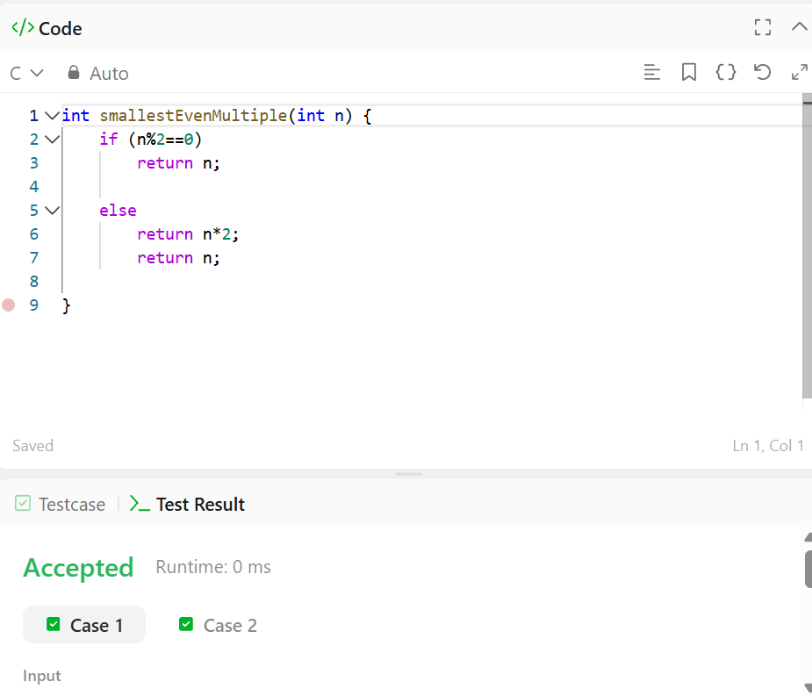
Question 12 https://leetcode.com/problems/number-of-steps-to-reduce-a-number-to-zero/
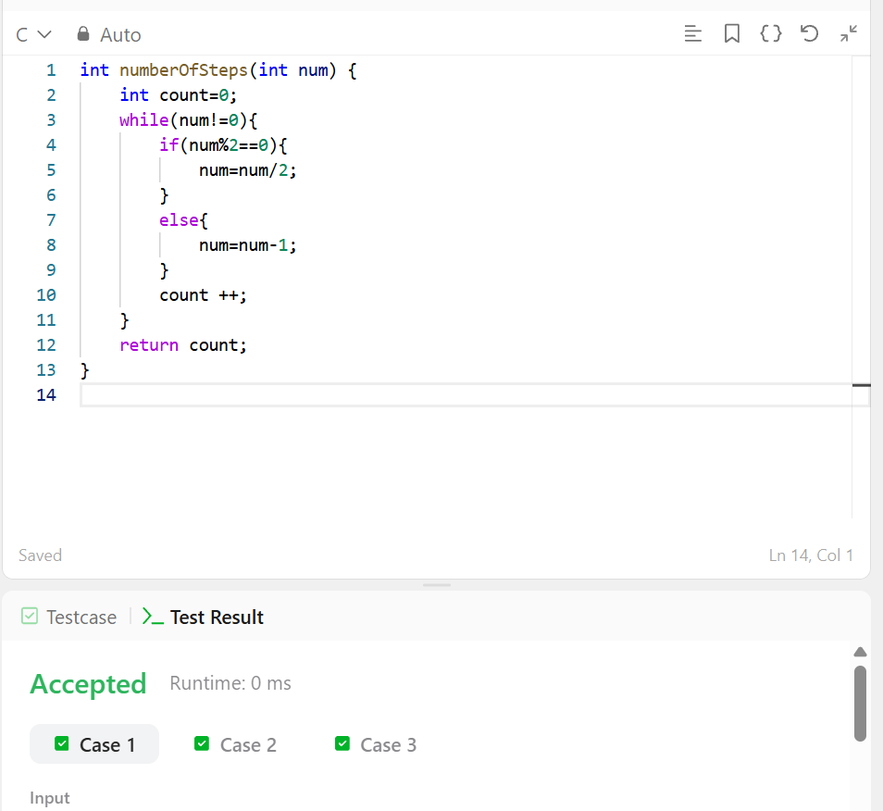

Question 13 https://leetcode.com/problems/number-of-steps-to-reduce-a-number-to-zero/submissions/2191078403/
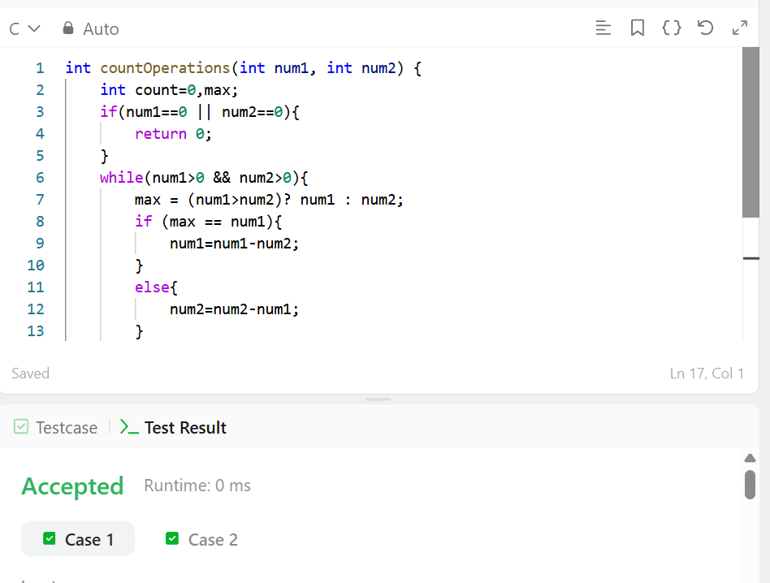
Question 14 https://leetcode.com/problems/count-odd-numbers-in-an-interval-range/submissions/2191079774/
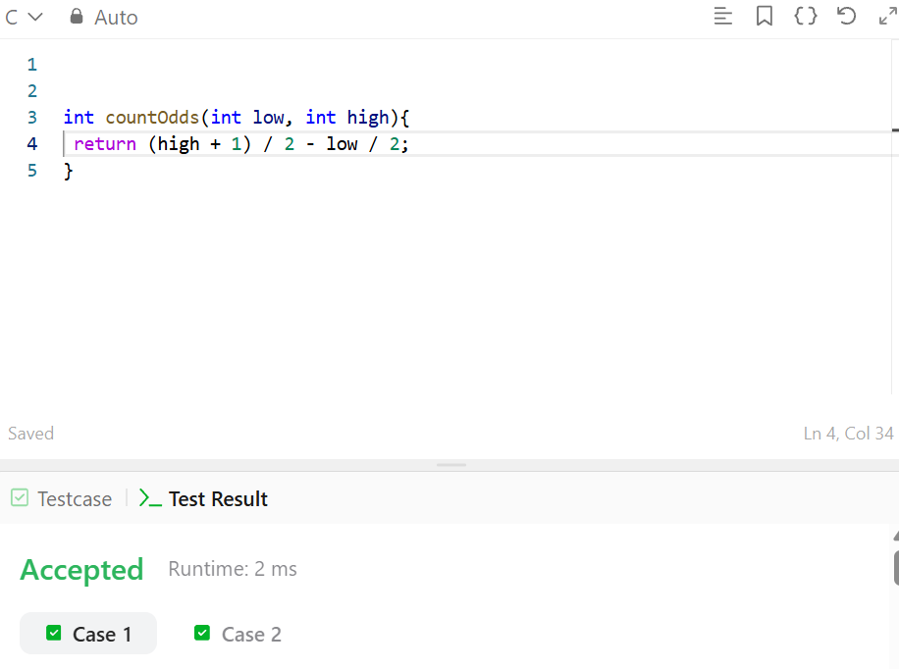
Question 15 https://leetcode.com/problems/sum-multiples/description/
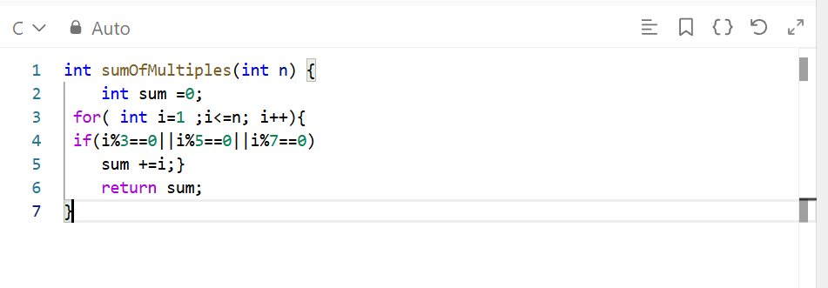
Question 16 https://leetcode.com/problems/subtract-the-product-and-sum-of-digits-of-an-integer/
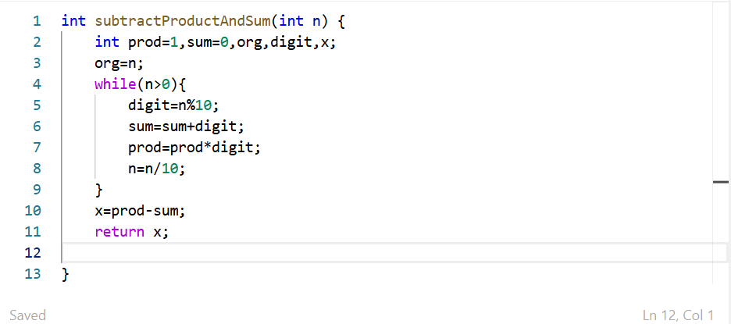
Question 17 https://leetcode.com/problems/count-the-digits-that-divide-a-number/
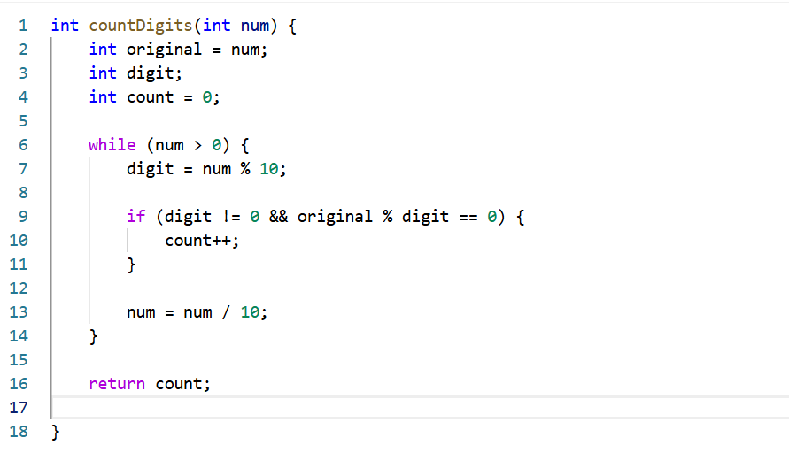
Question 18 https://leetcode.com/problems/palindrome-number/
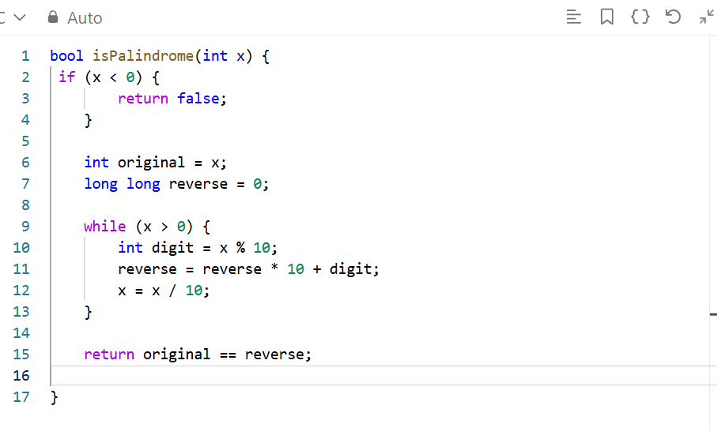
Question 19 https://leetcode.com/problems/reverse-integer/
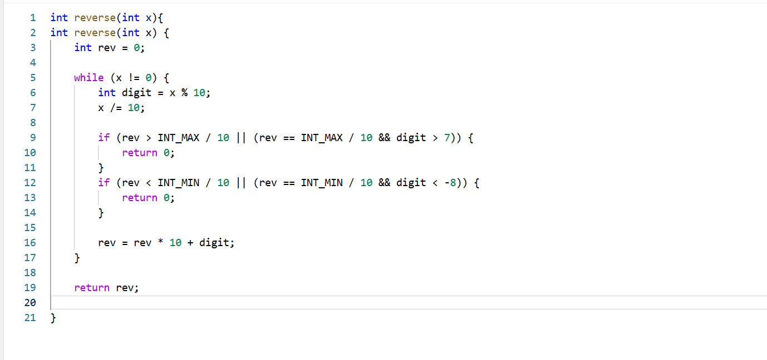
Question 20 https://leetcode.com/problems/power-of-two/
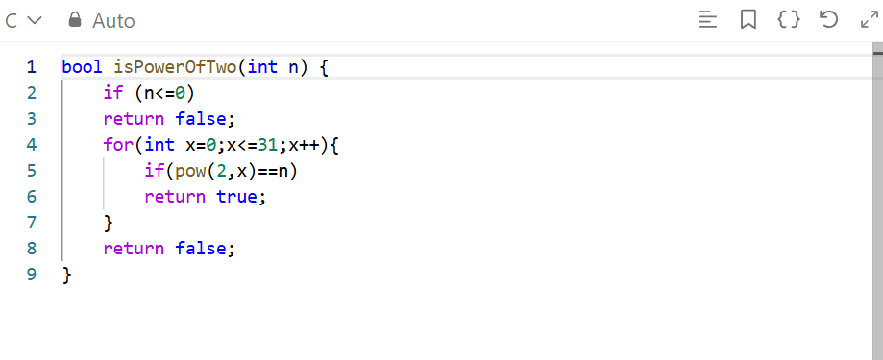
Question21 https://leetcode.com/problems/power-of-three/description/
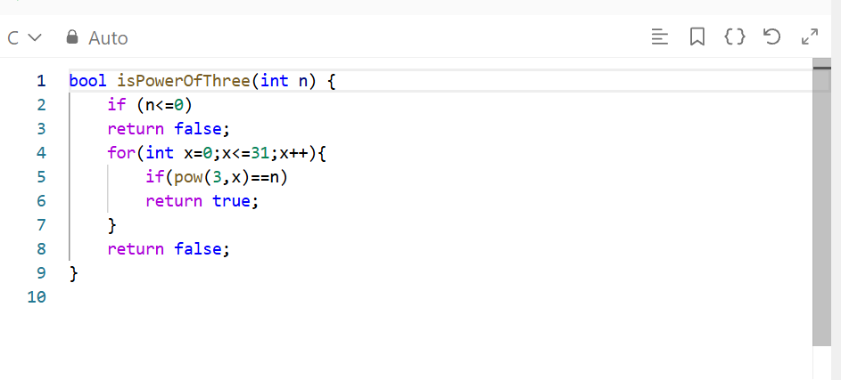
Question 22 https://www.hackerearth.com/practice/basic-programming/input-output/basics-of-input-output/practice-problems/algorithm/find-factorial/
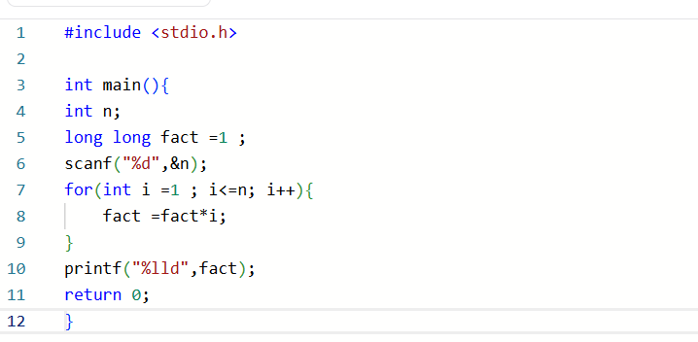

Question 23 https://www.hackerearth.com/practice/basic-programming/input-output/basics-of-input-output/practice-problems/algorithm/count-divisors/
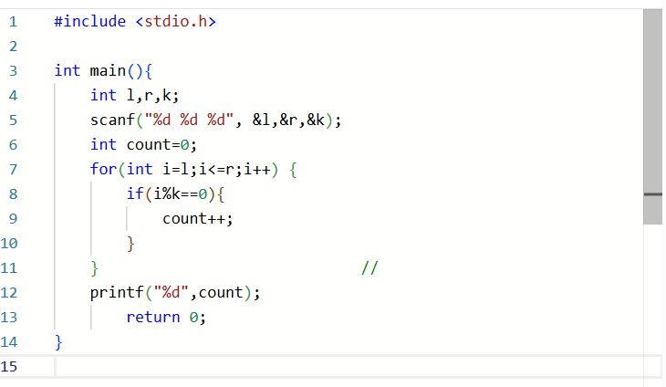
Question 24 https://www.hackerearth.com/problem/algorithm/prime-numbers/
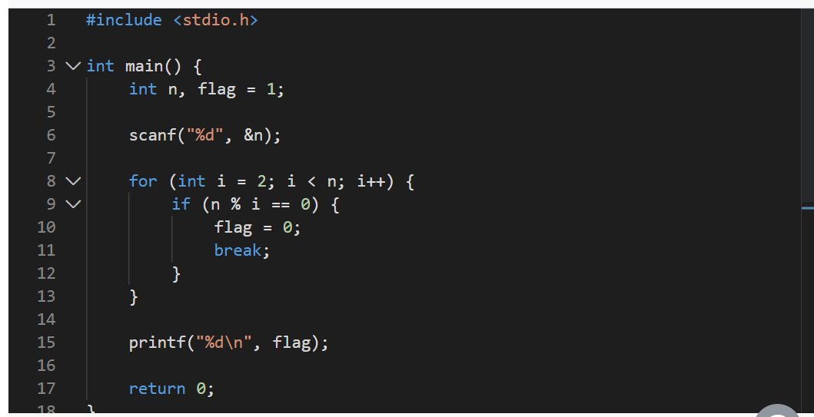
Question 25 https://leetcode.com/problems/perfect-number/
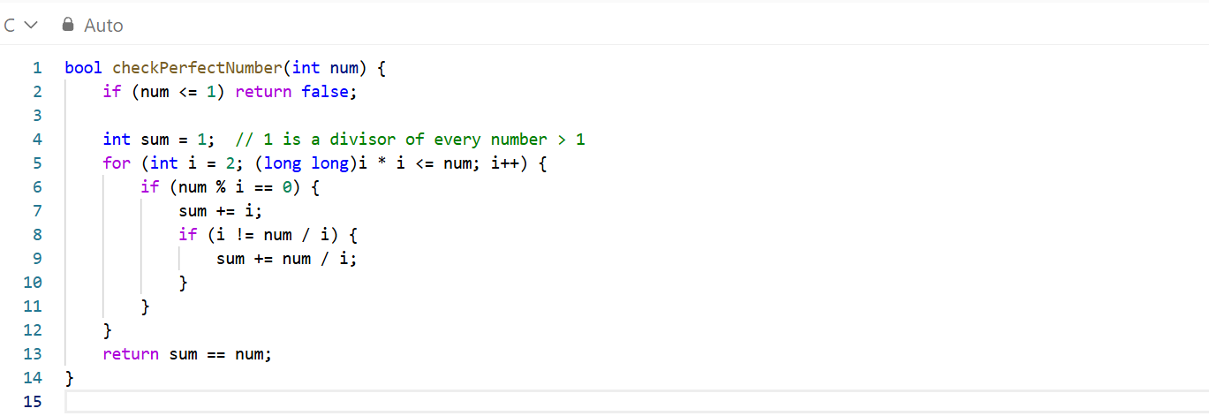
Question 26 https://www.hackerrank.com/challenges/printing-pattern-2/problem


